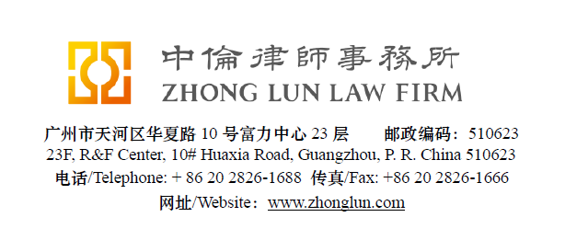

Invoice / 收款通知书

|  |  |  |  |
| --- | --- | --- | --- |
| **Date**  **日期** | 28/07/2019 | **ZL Invoice Reference[1]**  **中伦收款通知编号** | 055325-0001/015 |
| **Client**  **客户** | | **桂林漓江高尔夫乡村俱乐部实业有限公司**  Attn: Ben LIN  广西桂林市竹江路桂林华侨农场内 | |
| **Subject Matter**  **事项** | General | **Service Period**  **服务期限** | June 2019 |
| **Legal Fee**  **律师费** | RMB 52,370 | **Reimbursement**  **报销费用** |  |
| **Sum Now Due[2]**  **总应付款** | RMB 52,370 | | |

Please make the payment to the banks account as follows:

请将上述款项付至下列账户：

|  |  |  |  |
| --- | --- | --- | --- |
| **Account Number**  **账号** | 1209 0403 9310 502 | Swift Code **银行代码** | CMBCCNBS131 |
| **Account Name[3]**  **账户名称** | Beijing Zhong Lun Law Firm Guangzhou Office  北京市中伦（广州）律师事务所 | | |
| **Bank Name**  **开户行** | China Merchants Bank, Guangzhou Branch, R&F Center Subbranch  招商银行广州分行富力中心支行 | | |
| **Address**  **地址** | 2/28F R&F Center, 10 Huaxia Road, Guangzhou, China  广州市华夏路10号富力中心2/28楼 | | |

**Zhong Lun Law Firm 中伦律师事务所**

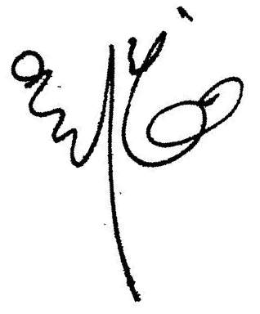

**Charge Details/收费明细**

To our Professional Charges for our service rendered in respect of the following:

中伦律师事务所就如下事宜提供了专业服务：

| **Date  日期** | **Description of Services 服务记录** | **Personnel 人员** | **Hours Spent 所用小时数** |
| --- | --- | --- | --- |
|  |  |  |  |
| 04/06/19 | Preparing the Minutes on the conference call about tax issues and sending the same to Mark GAO for comments. | Debby Z | 4.3 |
|  |  |  |  |
| 05/06/19 | Reviewing the Minutes on the conference call about tax issues prepared by Debby ZHOU. | Ashley H | 4.5 |
|  |  |  |  |
| 06/06/19 | Reviewing the comments to Minutes on the conference call about tax issues prepared by Ashley HU. | Mark G | 1.1 |
|  |  |  |  |
| 07/06/19 | Reviewing the Minutes on the conference call about tax issues prepared by Debby ZHOU and commented by Mark GAO and sending the same to client. | Kent W | 0.7 |
|  |  |  |  |
| 14/06/19 | Reviewing the draft SPA with Eastern Capital and the draft confirmation on termination prepared by Debby ZHOU and sending the same to client. | Kent W | 3.1 |
|  |  |  |  |
|  | Preparing the draft SPA with Eastern Capital and the draft confirmation on termination. | Debby Z | 9.3 |

For clarification we have set out below a table showing the hours spent by ZL personnel:

为明确起见，我们在下表中列明了中伦律师事务所工作人员所花费的时间：

|  |  |  |  |
| --- | --- | --- | --- |
| **Personnel**  **人员** | **Hours Spent 总计小时数** | **Rate (RMB)/hour 每小时费率** | **Legal Fee (RMB)**  **律师费 (人民币)** |
|  |  |  |  |
| Kent WOO/Mark GAO | 4.9 | 3,300 | 16,170 |
|  |  |  |  |
| Debby ZHOU/Michael WONG/Ashley HU | 18.1 | 2,000 | 36,200 |
|  |  |  |  |
|  |  | **Total/小计:** | **52,370** |

1. **Please kindly indicate the ZL Invoice Reference number on your bank processing document and provide us a copy of the bank confirmation for the payment. /请在银行付款单据上标明中伦收款通知编号，并向我方提供相关银行确认书。**
2. **Please pay equivalent foreign currency if a RMB account is not available. /若未能支付人民币，请支付等值外币。**
3. **Please indicate the FULL name in the bank advice and state the FULL name at the remark or note section on the bank advice./ 请在银行付款单据上列明全称并在汇款附言或备注栏填入收款人全称。**